Infosys Springboard Virtual Internship

CrowdCount - People Counting Using Video Analysis
Milestone 3: LIVE DASHBOARD

\

Name: Keerthana S
Date : 22-12-2025
1. Introduction
This Milestone focuses on transforming real-time people detection data into a live, interactive dashboard. In this phase, the system connects the backend crowd-counting logic with a frontend user interface to display live people counts, zone-wise statistics, charts, heatmaps, alerts, and downloadable reports. This milestone emphasizes real-time data streaming, visual analytics, and user-friendly monitoring, enabling effective analysis of crowd behavior and safety conditions in public areas.

2. Key Features Implemented
• Real-time people counting using live camera/video input
• Backend API for streaming live crowd data to the dashboard
• Interactive live dashboard displaying total and zone-wise counts
• Auto-refresh mechanism for real-time updates without page reload
• Dynamic charts for visualizing crowd trends over time
• Heatmap visualization to highlight high-density movement areas
• Threshold-based alert system for overcrowding detection
• Export functionality to download crowd data in CSV/PDF format
• Responsive and user-friendly dashboard interface

3. System Workflow
• Video Input Acquisition
The system captures live video frames from a camera or pre-recorded video source.
• Person Detection & Tracking
Each frame is processed using a deep learning–based detection model to identify people and assign unique tracking IDs.
• Counting & Zone Analysis
Detected individuals are counted globally and within user-defined zones to generate real-time statistics.
• Backend Processing
The backend aggregates live counts, zone-wise data, heatmap information, and timestamps, and prepares them for transmission.
• Data Transmission
Processed data is sent to the frontend through API endpoints at regular intervals.
• Live Dashboard Visualization
The dashboard displays total count, zone-wise metrics, charts, heatmaps, and alerts in real time.
• Alerts & Reporting
Threshold breaches trigger alerts, and historical data can be exported as CSV/PDF reports for analysis.

4. Code Implementation
index.html
<!DOCTYPE html>
<html lang="en">
<head>
<meta charset="UTF-8">
<meta name="viewport" content="width=device-width, initial-scale=1.0">
<title>CrowdIntel | Smooth One-Screen Analytics</title>
<link href="https://cdn.jsdelivr.net/npm/bootstrap@5.3.3/dist/css/bootstrap.min.css" rel="stylesheet">
<script src="https://cdn.jsdelivr.net/npm/chart.js"></script>
<link href="https://fonts.googleapis.com/css2?family=Inter:wght@400;500;600;700&display=swap" rel="stylesheet">
<style>
:root {
--bg: #0f172a;
--card-bg: rgba(30, 41, 59, 0.7);
--border: rgba(255, 255, 255, 0.1);
--accent: #3b82f6;
--danger: #ef4444;
}

body, html {
height: 100vh;
margin: 0;
overflow: hidden;
background-color: var(--bg);
color: #f1f5f9;
font-family: 'Inter', sans-serif;
}

.dashboard-container {
display: grid;
grid-template-columns: 350px 1fr;
grid-template-rows: 70px 1fr 200px;
height: 100vh;
gap: 12px;
padding: 12px;
}

header {
grid-column: 1 / -1;
background: var(--card-bg);
border: 1px solid var(--border);
border-radius: 12px;
display: flex;
align-items: center;
justify-content: space-between;
padding: 0 20px;
backdrop-filter: blur(10px);
}

.sidebar {
grid-row: 2 / 4;
background: var(--card-bg);
border: 1px solid var(--border);
border-radius: 12px;
display: flex;
flex-direction: column;
padding: 15px;
overflow: hidden;
}

.zone-list-scroll {
flex-grow: 1;
overflow-y: auto;
margin-top: 10px;
}

.main-content {
grid-row: 2;
background: var(--card-bg);
border: 1px solid var(--border);
border-radius: 12px;
padding: 20px;
position: relative;
}

.bottom-shelf {
grid-row: 3;
display: grid;
grid-template-columns: 1fr 1fr;
gap: 12px;
}

.metric-card {
background: var(--card-bg);
border: 1px solid var(--border);
border-radius: 12px;
padding: 15px;
}

.zone-item {
background: rgba(255,255,255,0.03);
border-left: 4px solid var(--accent);
border-radius: 6px;
padding: 12px;
margin-bottom: 8px;
display: flex;
justify-content: space-between;
align-items: center;
transition: transform 0.3s ease;
}

.zone-item.danger {
border-left-color: var(--danger);
background: rgba(239, 68, 68, 0.1);
}

.label-upper {
font-size: 0.7rem;
color: #94a3b8;
text-transform: uppercase;
font-weight: 600;
letter-spacing: 0.5px;
}

.stat-lg { font-size: 1.5rem; font-weight: 700; }
::-webkit-scrollbar { width: 4px; }
::-webkit-scrollbar-thumb { background: rgba(255,255,255,0.1); border-radius: 10px; }

.pulse {
height: 8px; width: 8px; background: #22c55e; border-radius: 50%;
display: inline-block; margin-right: 8px;
animation: blink 1.5s infinite;
}
@keyframes blink { 50% { opacity: 0.3; } }
</style>
</head>
<body>

<div class="dashboard-container">
<header>
<div>
<span class="pulse"></span>
<span class="fw-bold">Milestone 3: Live Crowd Analytics</span>
</div>
<div class="d-flex align-items-center gap-4">
<div class="text-end">
<div class="label-upper">Total Occupancy</div>
<div class="h4 mb-0 text-info fw-bold" id="totalCount">0</div>
</div>
<div class="text-end border-start ps-4">
<div class="label-upper">Last Update</div>
<div class="small text-muted" id="lastUpdated">--:--:--</div>
</div>
<a href="http://localhost:8000/export_csv" class="btn btn-primary btn-sm px-3">CSV Report</a>
</div>
</header>

<aside class="sidebar">
<h6 class="label-upper mb-3">Zone Breakdown</h6>
<div id="zoneContainer" class="zone-list-scroll"></div>
<div id="alertBox" class="mt-3 p-2 d-none rounded text-center small fw-bold" style="background: var(--danger); color: white;">
🚨 CAPACITY LIMIT EXCEEDED
</div>
</aside>

<main class="main-content">
<h6 class="label-upper mb-3">Population Dynamics</h6>
<div style="height: calc(100% - 30px);">
<canvas id="lineChart"></canvas>
</div>
</main>

<div class="bottom-shelf">
<div class="metric-card">
<h6 class="label-upper mb-2">Heat Intensity Profile</h6>
<div style="height: 130px;">
<canvas id="heatIntensityChart"></canvas>
</div>
</div>
<div class="metric-card">
<h6 class="label-upper mb-3">System Insights</h6>
<div class="row text-center">
<div class="col-6 border-end">
<div class="label-upper">Peak Zone</div>
<div class="h5 mt-1" id="peakZone">N/A</div>
</div>
<div class="col-6">
<div class="label-upper">Active Sensors</div>
<div class="h5 mt-1" id="sensorCount">0</div>
</div>
</div>
</div>
</div>
</div>

<script>
const ZONE_LIMIT = 35;
const MAX_POINTS = 30;
let lineChart, heatChart;
let labels = [];

function init() {
const chartDefaults = {
responsive: true,
maintainAspectRatio: false,
animation: {
duration: 1000, // Smooth 1-second transitions
easing: 'easeInOutQuad'
},
plugins: { legend: { display: false } },
scales: {
x: { grid: { display: false }, ticks: { color: '#475569', size: 10 } },
y: { grid: { color: 'rgba(255,255,255,0.05)' }, ticks: { color: '#475569' }, beginAtZero: true }
}
};

lineChart = new Chart(document.getElementById('lineChart'), {
type: 'line',
data: { labels: labels, datasets: [] },
options: {
...chartDefaults,
plugins: { legend: { display: true, position: 'top', labels: { color: '#94a3b8', usePointStyle: true, boxWidth: 6 } } },
elements: { line: { tension: 0.4 }, point: { radius: 0 } }
}
});

heatChart = new Chart(document.getElementById('heatIntensityChart'), {
type: 'line',
data: { labels: [], datasets: [{ data: [], borderColor: '#3b82f6', backgroundColor: 'rgba(59, 130, 246, 0.1)', fill: true, tension: 0.4, borderWidth: 2 }] },
options: chartDefaults
});
}

function updateData() {
fetch('http://localhost:8000/get_count')
.then(res => res.json())
.then(data => {
const now = new Date().toLocaleTimeString([], {hour: '2-digit', minute:'2-digit', second:'2-digit'});
document.getElementById('lastUpdated').innerText = now;

// 1. Update Labels
if (labels.length >= MAX_POINTS) labels.shift();
labels.push(now);

// 2. Process Zones & Sidebar UI
const zoneContainer = document.getElementById('zoneContainer');
zoneContainer.innerHTML = '';
let total = 0;
let peakVal = -1;
let peakName = 'None';
let limitReached = false;

Object.entries(data.zones).forEach(([name, count]) => {
total += count;
if(count > peakVal) { peakVal = count; peakName = name; }
const isOver = count > ZONE_LIMIT;
if(isOver) limitReached = true;

zoneContainer.innerHTML += `
<div class="zone-item ${isOver ? 'danger' : ''}">
<div>
<div class="label-upper" style="font-size: 0.6rem;">Zone Name</div>
<div class="fw-bold">${name}</div>
</div>
<div class="stat-lg ${isOver ? 'text-danger' : 'text-info'}">${count}</div>
</div>`;

// 3. Smooth Dataset Update
let dataset = lineChart.data.datasets.find(ds => ds.label === name);
if (!dataset) {
const colors = ['#3b82f6', '#10b981', '#f59e0b', '#ef4444', '#8b5cf6'];
dataset = {
label: name,
data: new Array(labels.length - 1).fill(null),
borderColor: colors[lineChart.data.datasets.length % colors.length],
borderWidth: 2,
pointRadius: 0,
tension: 0.4
};
lineChart.data.datasets.push(dataset);
}
if (dataset.data.length >= MAX_POINTS) dataset.data.shift();
dataset.data.push(count);
});

// Cleanup removed zones
lineChart.data.datasets = lineChart.data.datasets.filter(ds => data.zones[ds.label] !== undefined);

// 4. Update Header & Insights
document.getElementById('totalCount').innerText = total;
document.getElementById('peakZone').innerText = peakName;
document.getElementById('sensorCount').innerText = Object.keys(data.zones).length;
const alertBox = document.getElementById('alertBox');
limitReached ? alertBox.classList.remove('d-none') : alertBox.classList.add('d-none');

// 5. Update Heat Chart
heatChart.data.labels = data.heat_timestamps || [];
heatChart.data.datasets[0].data = data.heat_intensity_history || [];

// Execute update with 'none' mode for smoother frame transition
lineChart.update();
heatChart.update();
})
.catch(e => console.error("Update failed"));
}

init();
setInterval(updateData, 1000);
</script>
</body>
</html>

5. Code Explanation
Index.html
This code implements a real-time crowd analytics dashboard using HTML, CSS, JavaScript, Bootstrap, and Chart.js. The layout is designed as a single-screen interface that displays total occupancy, zone-wise people counts, live population trends, heat intensity history, and system insights without requiring page reloads. The frontend continuously fetches live data from the backend API every second, processes zone-wise counts, calculates totals and peak zones, and updates the UI dynamically. Line charts visualize crowd movement over time, while threshold logic highlights overcrowded zones and triggers visual alerts when limits are exceeded. Overall, this dashboard transforms live detection data into a smooth, interactive, and visually clear monitoring system suitable for real-time crowd management.

6. Output
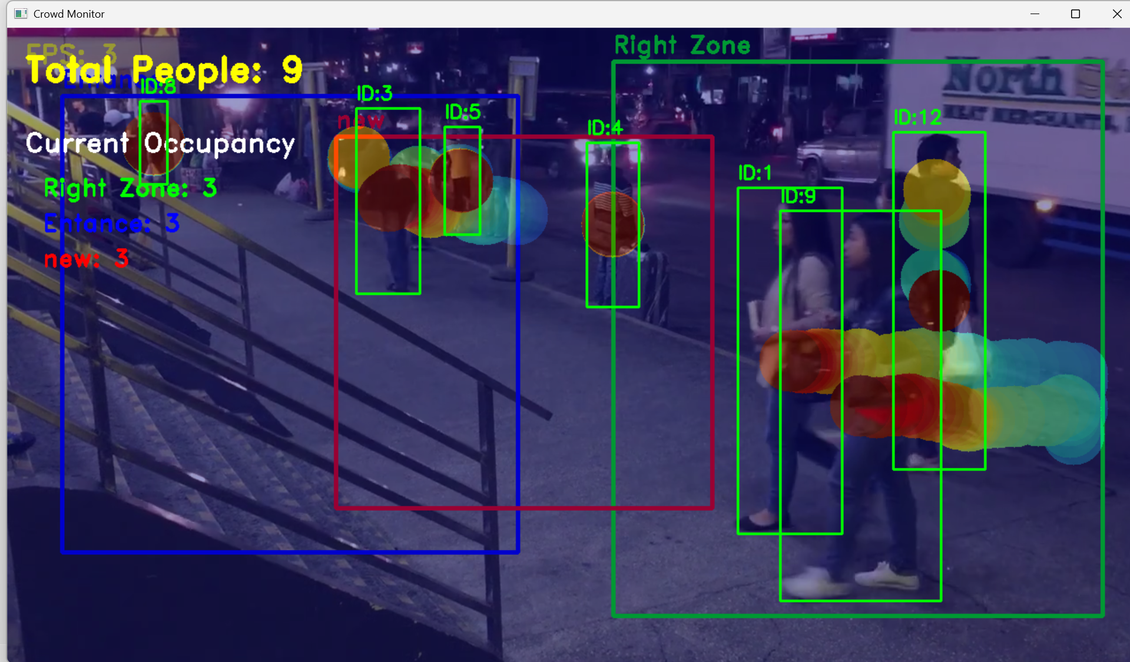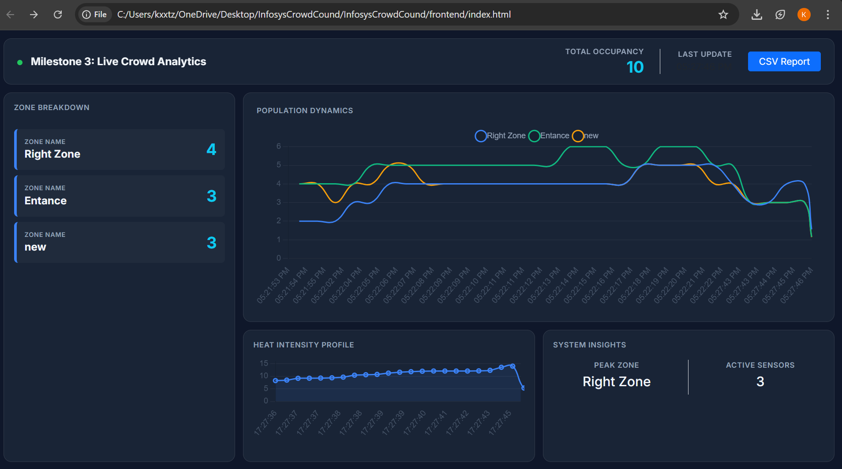
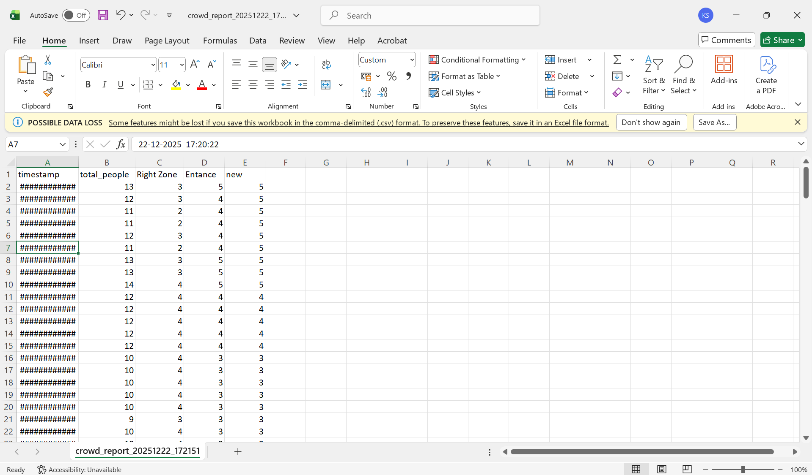

7. Conclusion
This milestone successfully delivers a complete real-time crowd analytics dashboard that transforms raw people-detection data into meaningful, visual, and actionable insights. By integrating a responsive frontend with a live backend data stream, the system continuously displays total and zone-wise occupancy, dynamic charts, heat intensity trends, and automatic overcrowding alerts. The implementation demonstrates smooth real-time updates without page reloads, clear visualization for quick decision-making, and practical features such as CSV report export for analysis and documentation. Overall, this milestone bridges the gap between detection and real-world usability, making the project suitable for live monitoring, safety management, and future scalability.

